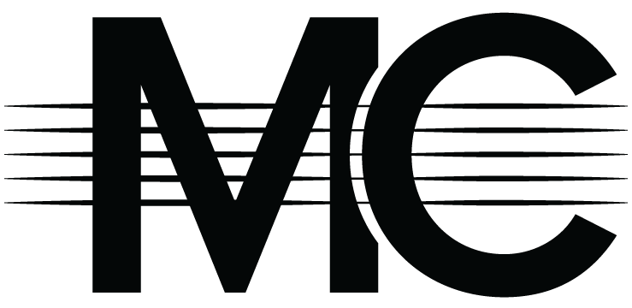
Title
Artist, Year (Key of ?, Original)
CHORDS:
Eb Standard Tuning
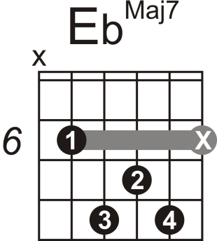
for Bridge only
65% scale
(8x7=56 chords)
Continued at back of page

Alternate (for Acoustic):

